What you need to do to add signals to your module: a primer
Version 1.00
HUB Signaling Committee
June 12, 2013

The goal of this document is provide a straightforward and hopefully simple recipe for what a HUB module group member needs to do to add signaling to their module. The signal committee has worked on this project for over 2 years now and has provided a roadmap. In any project such as this some decisions and compromises had to be made that affect all how the goal of signaling a modular railroad can be accomplished. This document will do its best to provide module members with the list of what is needed, what things must be done, what things should not be done and links to resources on the internet and our webpage to help. In addition, members of signal committee can be contacted for help and advice. The term “active” module will be used to describe a module with signaling capability.
- Required Hardware: This list does depend, in part, on the track plan but can be addressed even without a track plan. The necessary hardware list is:
  - A C/MRI SuperMini Board (SMini) [HUB gets discounts on these] One of these will usually be sufficient for a single 2x4 ft module.
  - A 5vDC regulated power supply to power the SMini Board [HUB has these available for members]
  - Replacement Terminal Strips (two required) for the wiring harness [See Diagram X]
  - As many C/RMI DCCOD occupancy detectors are needed for both the inner and out mainlines [HUB gets a discount on these as well]
  - A 12 vDC power supply to (does not need to be regulated) to power the DCCODs.
  - As many Common Anode signals as required by the track plan. [Many vendors]
- Required Software: A single CATS/JMRI file created by a tool called the CATS Designer. This graphic tool describes the physical track plan and all of the devices, detectors, blocks, SMINI boards, occupancy detectors, DCC controlled turnouts, turnout positions and signals contained on the module. At the outset, members of the signal committee will take on this task with the members until many members have become proficient with software.
- Required Permissions: You will need two permissions from the Modular Superintendent.
  - An assigned Address for the SMini Board
  - Assignment of Accessory Decoder addresses for Tortoises
- The Wiring: With either a new passive or a current existing passive module, the outer main was wired to the red/black terminal pair, the inner main from the yellow/black terminal pair and third track from the blue/black terminal pair. Active modules have a different wiring and, of course, require segmenting the track into separately detectable blocks. Two rules: 1) Signal gaps only require gapping the outer rail (red/pink/yellow,grey or blue) but DCC booster gaps (which may occur at a signal gap) require double gapping. Furthermore, modules need to have the capacity to can communicate their occupancy information to the two modules flank an active module on either side. The tracks that abut the joiner tracks are referred to as “end track segments” and those that are between end track segments as “intervening segments.”
  - Outer Main: Consider an eastbound train travelling on the outer main will enter from the west. The first track segment it will come upon is the west end track segment. This track segment is powered from left hand red/black pair from coming from the module the active module’s left. Both power and occupancy information are on those wires. As the train proceeds easterly, it will encounter one or more intervening segments. These are wired from pink/black terminals and each segment must provide its own DCCOD to determine occupancy. In diagram 2 below, the example shows 2 such track segments. The last track the train will encounter before hitting the east end joiner track is the East end segment. This segment is also powered from pink/black pair and also has its own DCCOD. However, the wire to this track segment feeds the red terminal on the right hand side of second terminal strip. This provides both power and occupancy information to the module to the active modules right. This is how we get power and more importantly occupancy information from unaltered existing passive modules. [See Diagrams 1-5 below]
  - Inner Main: The situation is the same for the inner main but the color of the terminals is different. A Westbound train travelling on the inner main will enter from the east. The first track segment it will come upon is the east end track segment. This track segment is powered from right hand yellow/black pair from coming from the module the active module’s left. Both power and occupancy information are on those wires. As the train proceeds easterly, it will encounter one or more intervening segments. In diagram 3 below, the example shows 2 such track segments. These are wired from grey/black terminals and each segment must provide its own DCCOD to determine occupancy. The last track the train will encounter before hitting the west end joiner track is the West end segment. This segment is also powered from grey/black pair and also has its own DCCOD. However, the wire to this track segment feeds the yellow terminal on the left hand side of first terminal strip. This provides both power and occupancy information to the module to the active module’s left. [See Diagrams 1-5 below]
  - Third Track: The third track is powered as before using the blue/black pair. Module owners can choose to add occupancy to third track blocks at their discretion but occupancy detection on the third track is entirely optional. One important rule regarding third track. No occupancy information can be passed to an adjoining module on either side across the joiner track. Another way of stating this is that the end segments on third tracks must not have DCCODs on them.

Diagram 1: Module with joiner tracks and “passive end segments” only
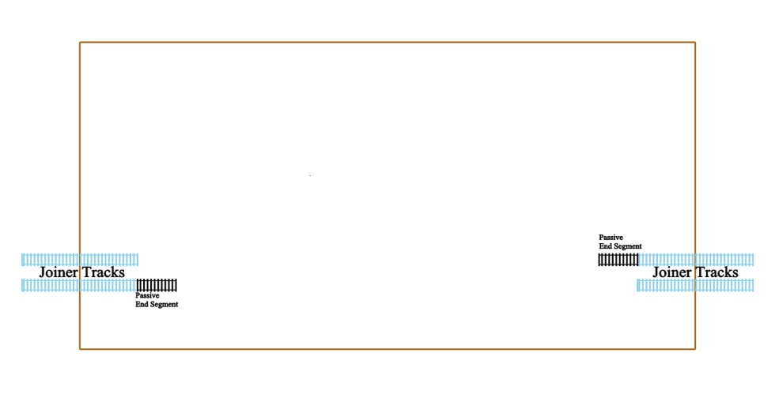

Diagram 2: Module outer main with passive end segments and intervening segments
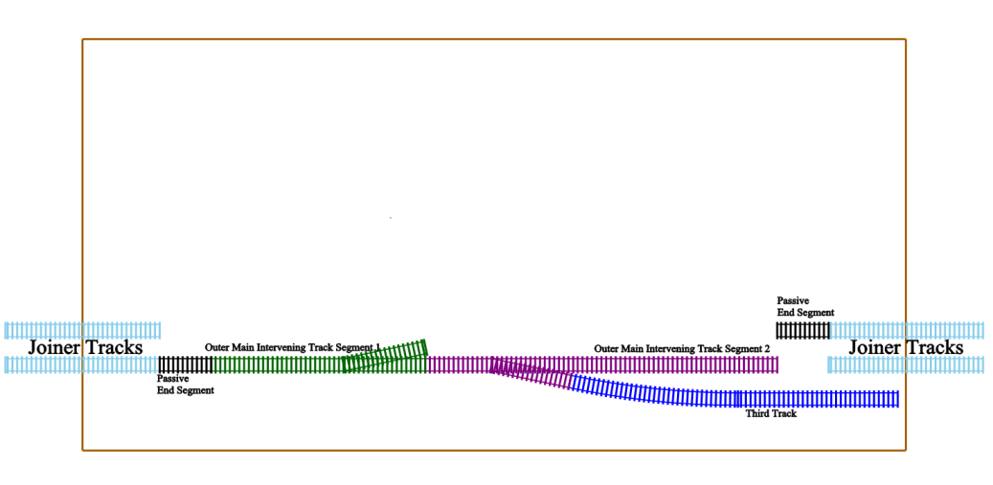
Diagram 3: Module both mains with passive end segments and intervening segments
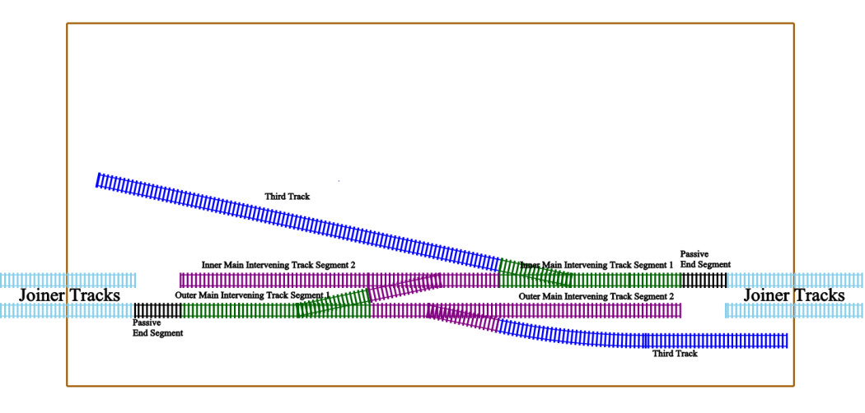

Diagram 4: Module both mains all track segments shown
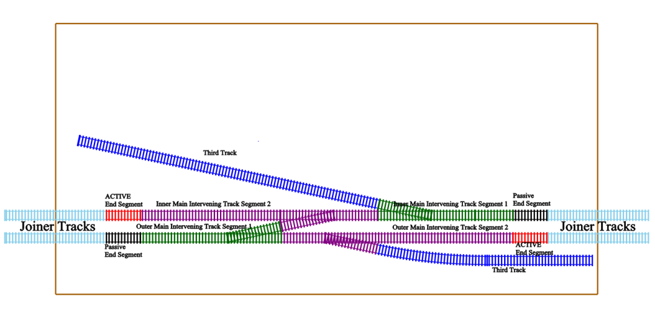
Diagram 5: Wiring Schematic for Inner and Outer Mains
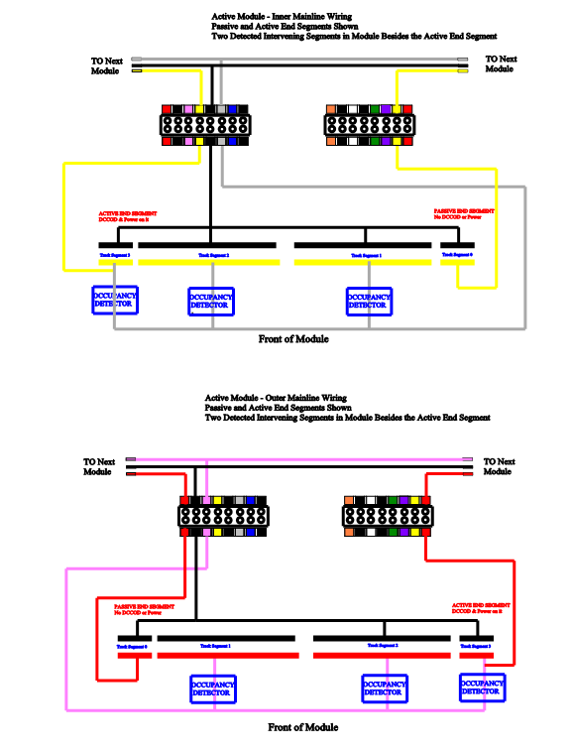

Figure 6 Terminal Strip Conventions
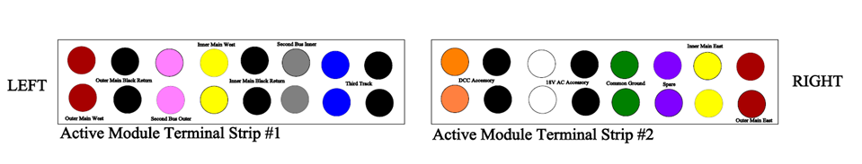
- Signals: A common anode signal capable of showing three red, yellow and green will have three separate LEDs, one for each color [Diagram 6]. Such a signal will have 4 wires per signal head, one for each color plus one for the common anode. This will work whether the LEDs are arranged vertically as in a D-type signal, in a triangular arrangement as in a G-type signal or all in the same housing as in a searchlight signal [Diagram 7]. The key thing to note is that common anode signals will all have 4 wire, one per colon and a common anode.
Signal Sources: The table below provides some sources for signals
Vendor | Website
BLMA | http://www.blmamodels.com
Custom Signal Systems: | http://www.customsignalsystems.com/
Integrated Signal Systems: | http://www.integratedsignalsystems.com/
NJ International: | http://www.njinternational.com/
Oregon Rail Systems: | http://www.oregonrail.com/
South Bend Signal Company: | http://www.sbsignal.com/
Tomar: | http://www.sbsignal.com/

Diagram 7: Wiring for a common anode three light signal
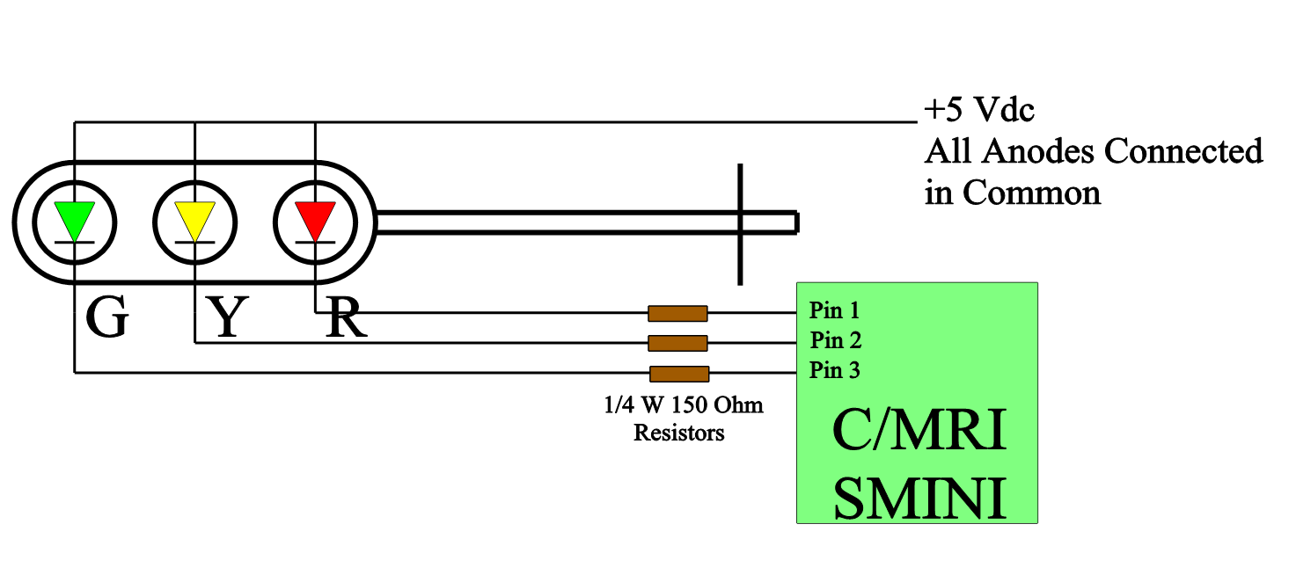

Diagram 8: Different Signal Heads but Each has 4 Wires and a Common Anode (+5vDC)
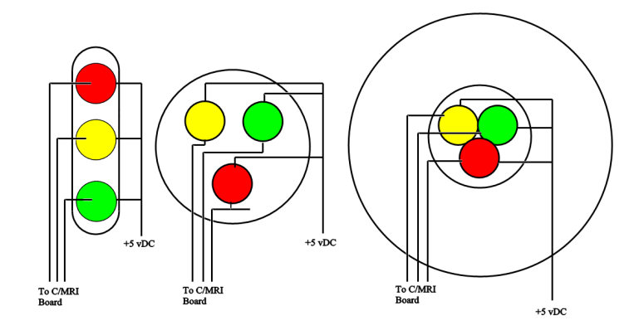
Searchlight
G-Type
D-Type

Signal placement: While this can be a long discussion, here are a couple of guidelines from the Masters at the 74th NMRA Convention in Milwaukee.
- All entrances to the main lines should be protected by a signal. This equates to having 3 signals around all turnouts and is often referred to as an OS section. [Diagram 9] You can think of this as a triangle around each frog.
Diagram 9: Triangular Configuration of an OS Section
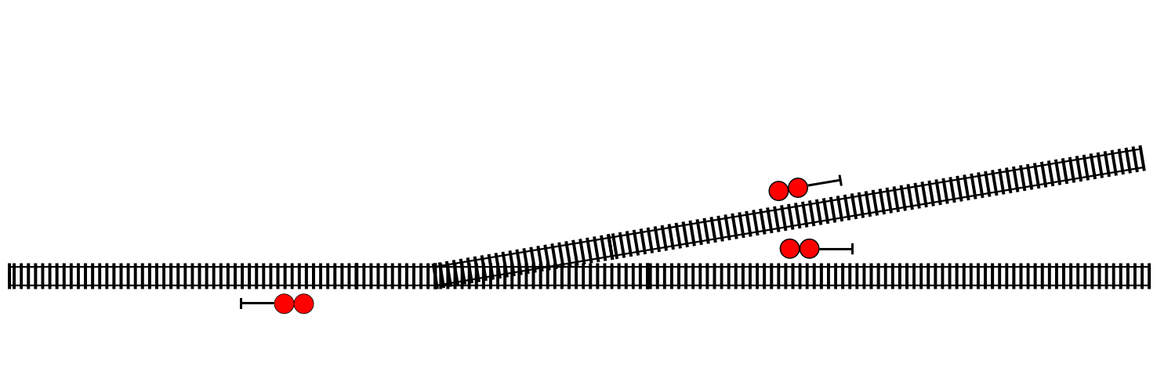
- Mike Burgett, who is an executive at in charge of signals for the CP, showed diagram 10 below as a guide to physical placement of signal masts. Recommended prototypical placement is at least 16 ft beyond the clearance point and 40 ft in front of the points.
Diagram 10. Signal Placement
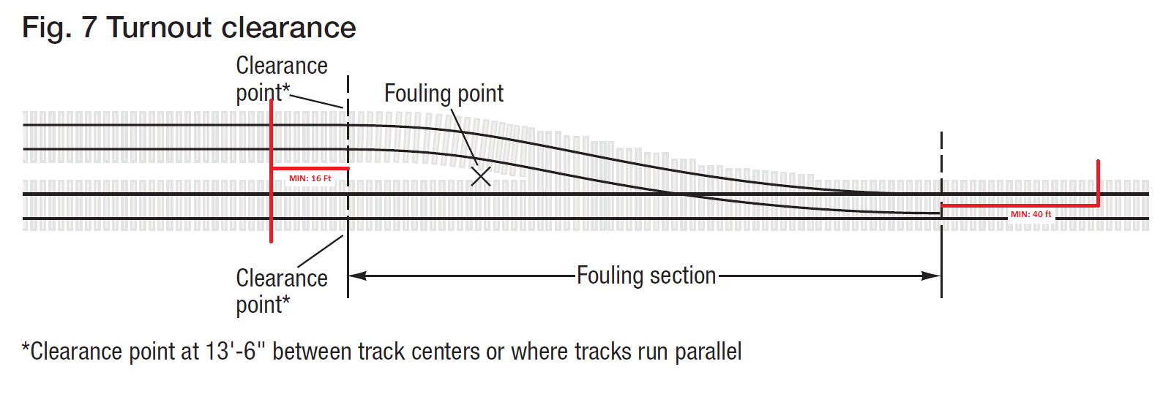

- Turnouts: There are a few key points to remember with turnouts.
    - It is increasingly important that mainline turnouts are controllable by accessory DCC decoders. Additionally, it is critical that mainline turnouts provide feedback to the dispatcher panel telling the point position. Fortunately this is easy with Tortoise or Cobalt powered motors. You just use one of the sets of switches included in the turnout motors. The center pole connects to signal ground and one of the other poles connects to a CMRI input pin. This will provide on and off information which can be equated to straight or diverting position of the points.
    - There are now 3 different methods to throw a turnout: 1) from a control panel, 2) from a panel and from the dispatcher’s panel. With signaling it is important that all three of these methods remain in synch. This is one of the challenges of setting up and wiring turnouts on active modules. Clearly all three methods don’t have to be employed. For example, you could omit a physical panel. However, you cannot ignore throws from a throttle or throws from the dispatcher panel.
    - Most commercially available DCC accessory decoders provide a method for connecting pushbuttons for panel control – take advantage of them. Consider panels such as those on Upton yard or Tipple.
    - Powered Frogs: Be careful powering your frogs. It is important that the power for the frog come from the same block that encloses the turnout. The train will operate fine with any source of the power but if that power comes from another block it will appear occupied when a train hits the frog. This is something you definitely don’t want.

